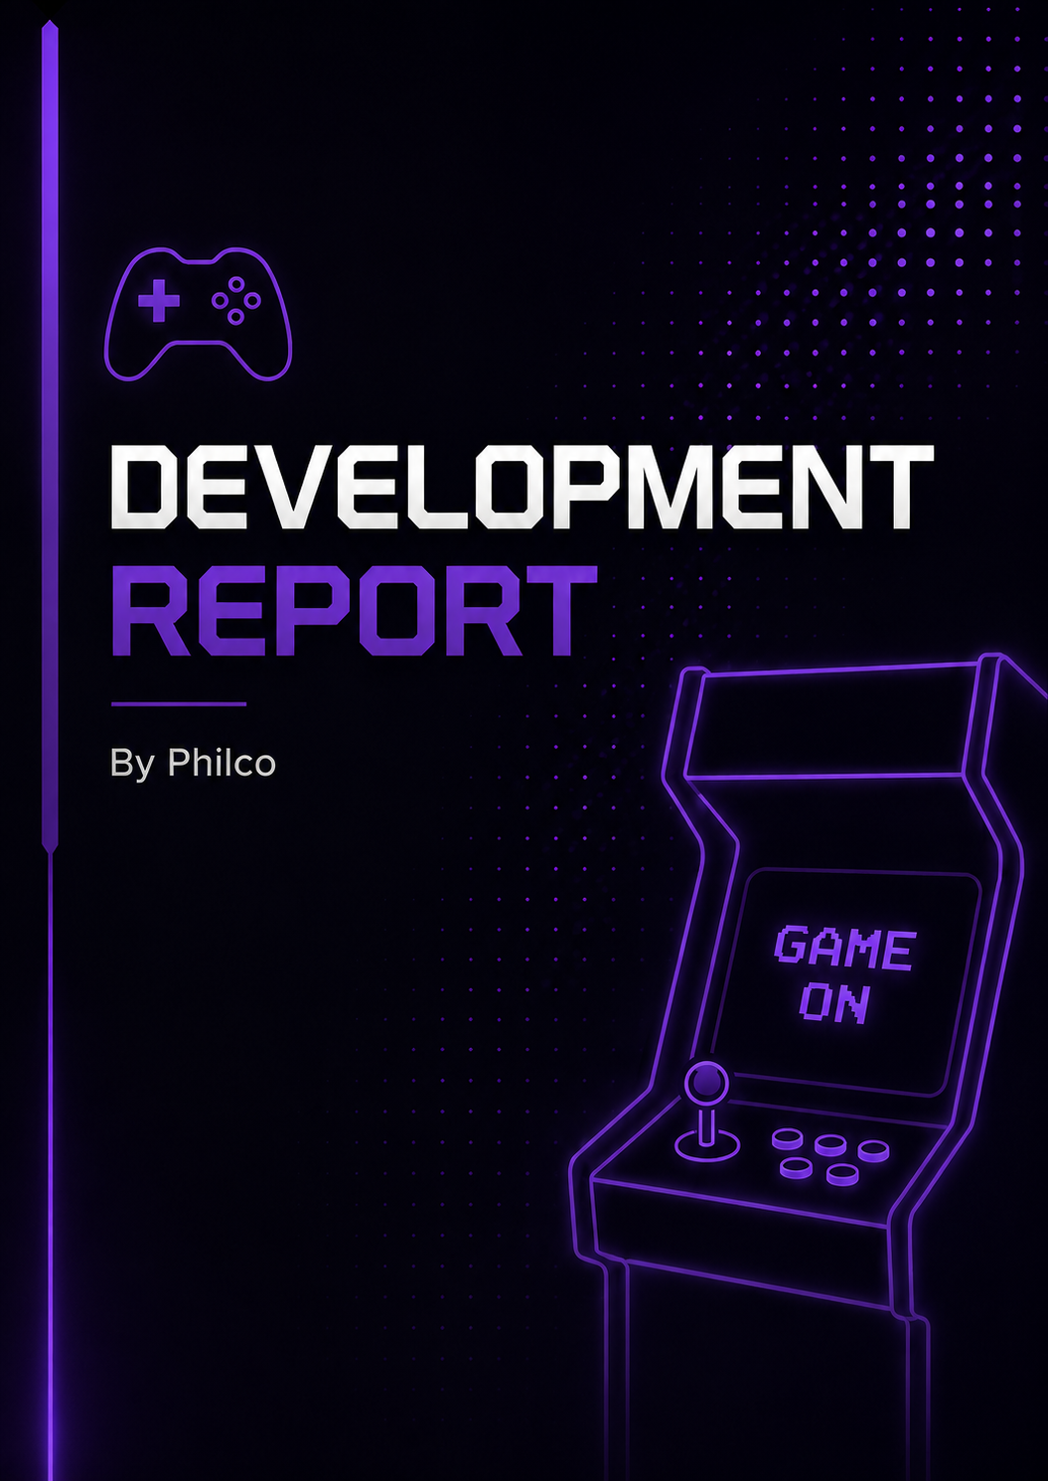


Table of Contents
Introduction 3
Overview of the developed solution 4
Technologies Used 4
Software Design 5
Main Menu System 5
Game Design 6
Object-Oriented Design 6
Wireframes and User Interface Design 7
Main Menu Design 7
Maze Game Design 7
User Interface Design Choices 8
Program Structure and Code Design 9
Project Structure 9
Naming Conventions 9
Internal Documentation 9
Maze Game Logic 10
Archery Game Logic 10
Duck Shooting Game Logic 10
Leaderboard System 11
Testing Strategy 12
Types of Testing Used 12
Testing Process 12
Test Cases and Test Logs 13
Example Test Cases 13
Bugs Identified and Fixed 13
Installation Documentation 14
System Requirements 14
Installation Steps 14
Important Notes 14
User Documentation 15
Starting the Application 15

Controls 15
Maze Game Controls 15
Archery Game Controls & Duck shooting game 15
Gameplay Instructions 15
Maze Game 15
Archery Game 15
Duck Shooting Game 15
Legislation and Professional Considerations 16
Copyright 16
Data Protection 16
Accessibility 16
Evidence of Completed Deliverables 16
Development Summary 17


Introduction

The purpose of this project was to design and develop a retro arcade gaming application containing multiple integrated games within a single software package. The application was developed collaboratively as part of a group software development project and aimed to demonstrate programming ability, software design, teamwork and project management skills.
The final application was created using Java and Java Swing and contains multiple playable retro style mini games integrated through a central menu system. The software was designed around a retro arcade theme inspired by classic arcade machines and pixel-style games.
The final completed application includes:
- A graphical arcade style main menu
- Multiple playable games
- Integrated navigation systems
- Retro themed graphical user interface
- Timer and score systems
- Leaderboard functionality
- A runnable executable application
The project was developed using a structured software development lifecycle consisting of planning, design, development, testing and evaluation stages.


Analysis

The completed solution is a retro arcade gaming application developed using Java Swing. The application allows users to access several different arcade style mini games from a single graphical menu system.
The project was developed using object-oriented programming techniques and a modular structure. Each game was developed independently before being integrated into the final application through the main menu system.
The completed application contains:
- Main menu navigation system
- Maze game
- Archery game
- Duck shooting game
- Timer systems
- Score systems
- Leaderboards
- Graphical user interface
- Executable deployment package

Technologies Used
Technology | Purpose
Java | Core programming language
Java Swing | Graphical user interface
Maven | Build and dependency management
IntelliJ IDEA | Software development environment
GitHub | Version control and collaboration
Microsoft Teams | Team communication

The final system was successfully converted into a runnable executable application allowing users to easily launch and interact with the software.


Software Design

The software was designed using a modular object-oriented structure. This allowed each game to be developed separately while still integrating into a single arcade application.
A structured software development lifecycle was followed throughout the project:
- Planning
- Design
- Development
- Testing
- Evaluation
This development approach helped the team organise work effectively and monitor progress throughout the project lifecycle.

Main Menu System
The main menu system acts as the central navigation hub of the application. Users can launch individual games, return to the menu and close the application from this interface.
Figure 1: Arcadia3000 main menu showing game selection and navigation options.
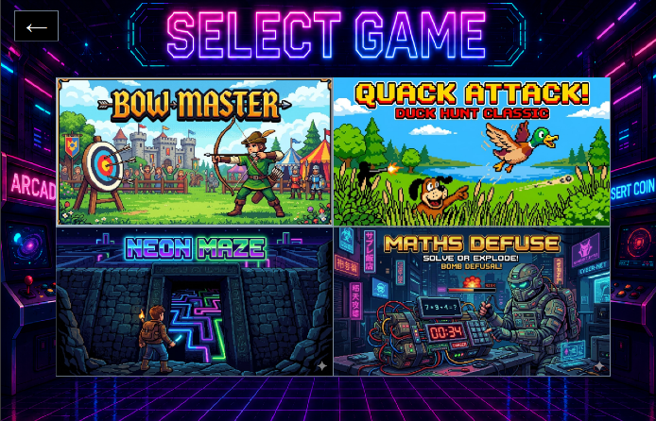
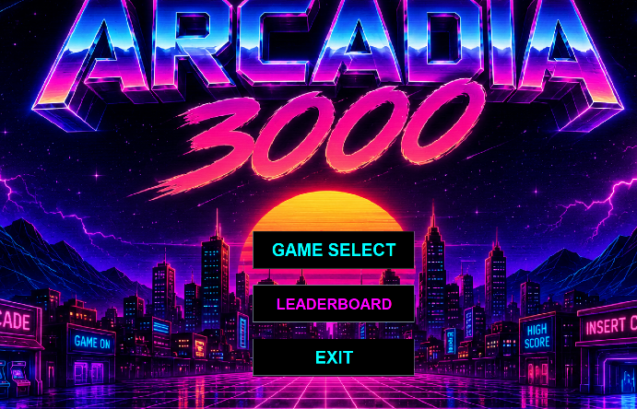

The menu system was designed using Java Swing components including:
- JFrame
- JPanel
- JButton
- JLabel
- ActionListeners

Action listeners were used to detect user input and launch the correct game when buttons were pressed.


Game Design
Each game was designed independently while following shared team standards to ensure consistency across the application. This included:
- Consistent retro colour palette
- Similar menu navigation systems
- Shared window dimensions
- Similar font styles
- Consistent user interface layouts

Object-Oriented Design
The project uses object-oriented programming principles including:
- Classes
- Methods
- Encapsulation
- Reusable components
- Modular code structure
Using object-oriented programming improved maintainability and allowed features to be separated into manageable components.


Wireframes and User Interface Design

Wireframes were created during the planning stage to visualise the structure and layout of the software before development began.
The wireframes helped the team:
- Plan menu layouts
- Organise game interfaces
- Visualise user navigation
- Maintain consistency across screens
- Reduce interface design problems during development

Main Menu Design
The main menu was designed with a retro arcade aesthetic inspired by classic arcade cabinets and pixel-style games.
The interface includes:
- Game selection buttons
- Navigation controls
- Background graphics
- Consistent retro styling

Maze Game Design
The maze game interface contains:
- Player character
- Maze walls and paths
- Timer system
- Start and finish areas
- Level progression system
The interface was designed to remain simple and easy to understand while still maintaining the arcade theme.


User Interface Design Choices
The user interface uses:
- Dark backgrounds
- Neon style colours
- Pixel inspired fonts
- Retro graphics
- Clear button placement
Consistency was maintained throughout the application by using shared visual design standards across all games.


Program Structure and Code Design
The application was developed using Java and organised into multiple packages and classes to improve maintainability and readability.

Project Structure
The project was separated into different folders and packages including:
Component | Purpose
Main Menu | Launches and manages navigation
Maze Game | Playable maze game
Archery Game | Arcade target game
Leaderboard System | Stores and displays scores
Assets Folder | Stores images and resources

Separating components into packages improved organisation and reduced code duplication.

Naming Conventions
Appropriate naming conventions were used throughout development.

Examples
Element type | Example
Class name | MazeGame
Method name | startGame()
Variable name | playerScore()
Constant | MAX_LEVEL

Meaningful naming conventions improved code readability and made debugging easier.

Internal Documentation
Comments were added throughout the code to explain:
- Collision detection
- Timer systems
- Game logic
- Movement systems
- Menu navigation


Maze Game Logic
The maze game was developed using keyboard movement and collision detection systems. The player navigates through the maze while avoiding walls and attempting to reach the finish area.
Features include:
- Keyboard movement controls
- Collision detection
- Timer system
- Level progression
- Win condition detection
Figure 2: Neon Maze gameplay showing player movement and maze navigation.
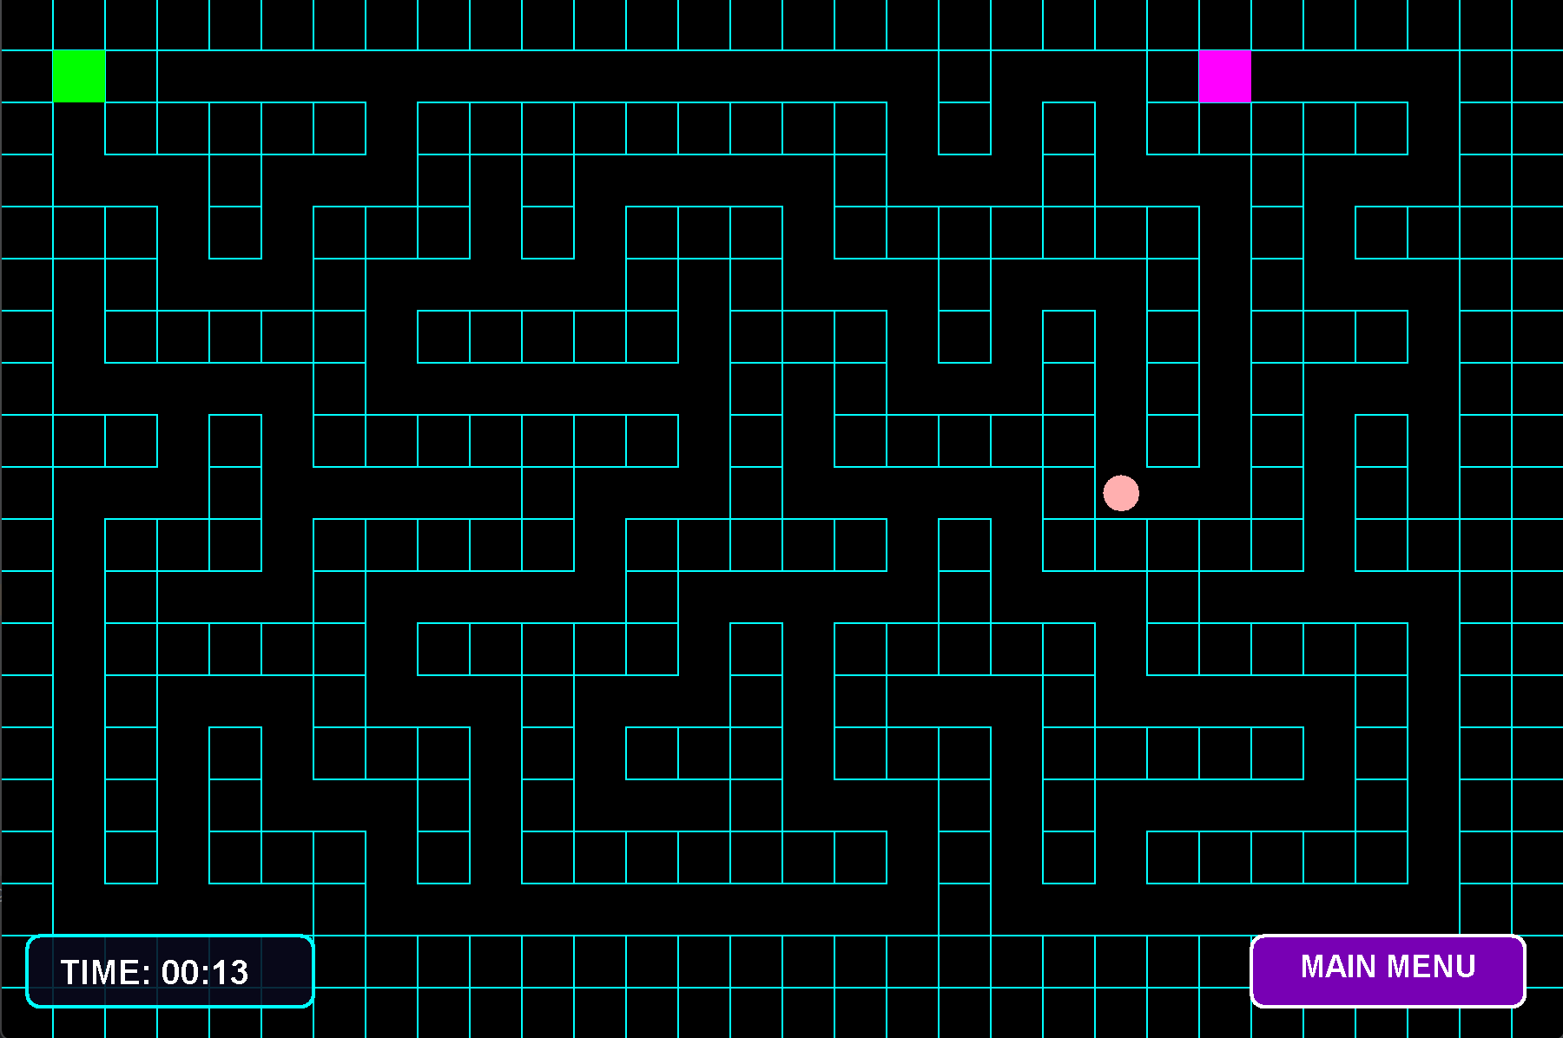

Archery Game Logic
The archery game was developed using mouse input and score tracking systems. The player aims and shoots arrows at targets to increase their score while attempting to achieve the highest accuracy possible.
Features include:
- Mouse aiming controls
- Target collision detection
- Score tracking system
- Real-time gameplay updates
- Accuracy-based gameplay
- Win and score conditions


Figure 4: Bow Master gameplay showing target scoring system and end game screen.
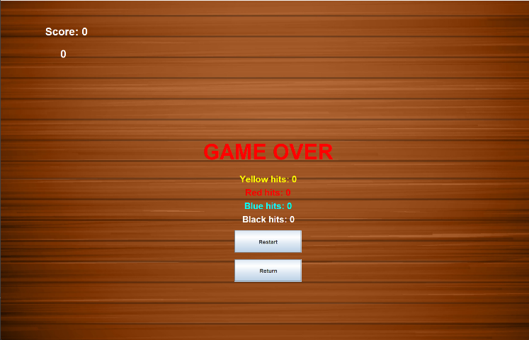
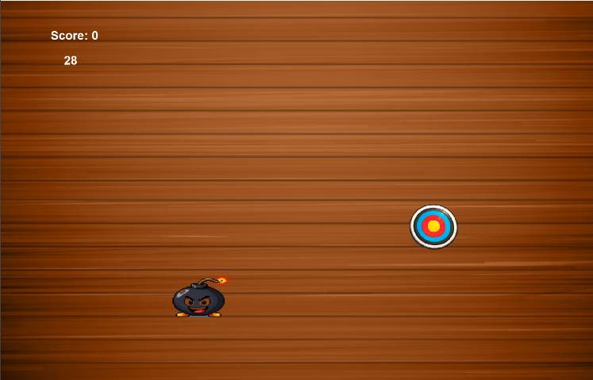

Duck Shooting Game Logic
The duck shooting game was developed using mouse input and moving target systems. The player shoots ducks flying across the screen while attempting to achieve the highest score possible before reaching the miss limit.
Features include:
- Difficulty selection system
- Mouse shooting controls
- Moving duck targets
- Score tracking system
- Miss counter system
- Game over condition detection
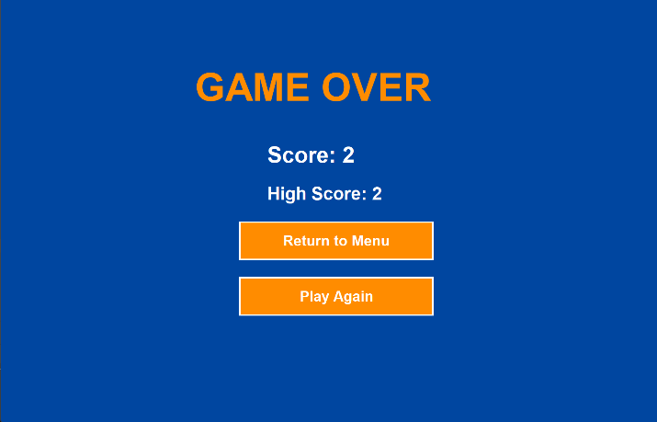
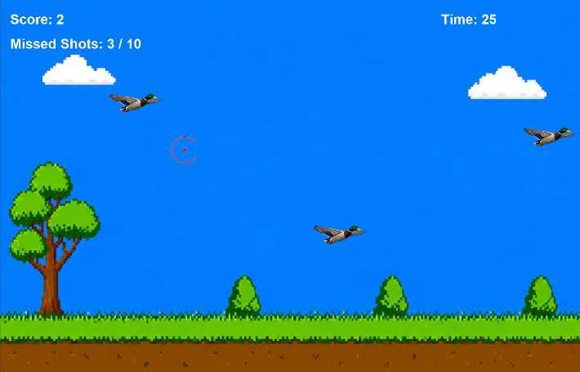
Figure 6: Quack Attack gameplay showing moving targets and score tracking and game over screen


Leaderboard System
The leaderboard system stores and displays player scores using an online Supabase database. Scores are uploaded and retrieved whenever a game is completed.
Figure 8: Supabase database tables used for online leaderboard storage.
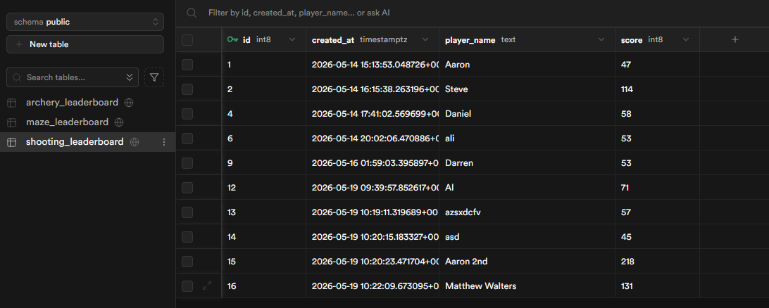

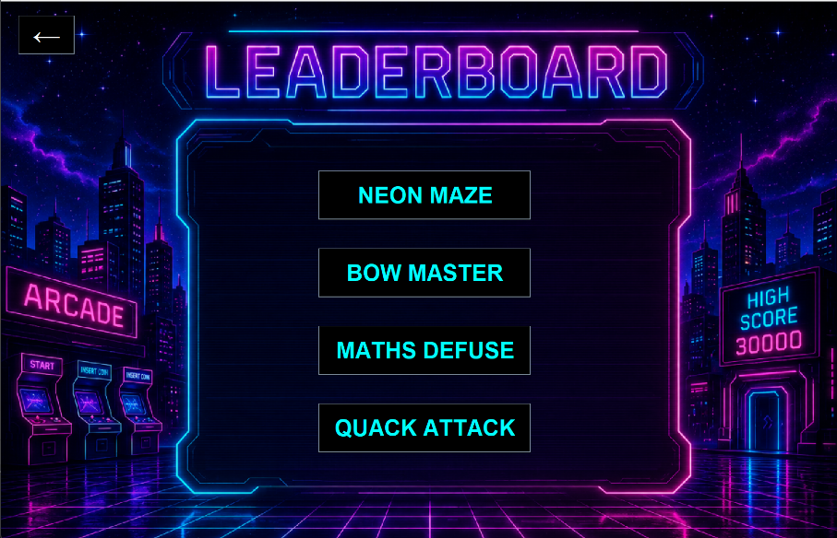
Figure 9: Game leaderboards are all saved and displayed correctly in-game matching the Supabase database.

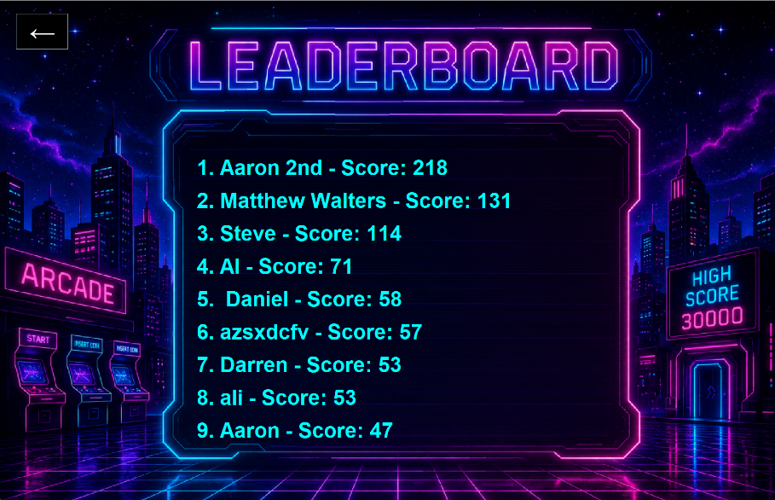


Testing Strategy
Testing was carried out continuously throughout development to ensure all software components functioned correctly.
The main aims of testing were to:
- Identify bugs and software errors
- Verify gameplay functionality
- Ensure menu navigation worked correctly
- Confirm score systems operated properly
- Ensure application stability
- Verify games integrated correctly into the final system

Types of Testing Used
Testing type | Purpose
Functional Testing | Verify game features operate correctly
User Interface Testing | Check menus and buttons function correctly
Integration Testing | Ensure games work correctly together
User Testing | Gather feedback from users
Regression Testing | Ensure fixes do not create new problems

Testing Process
Games were tested individually before integration into the final application. Once integration was completed, full application testing was carried out.
Testing was repeated regularly throughout development to reduce the risk of major bugs appearing during final deployment.
Any issues identified during testing were documented and corrected before the final application was packaged as an executable file.


Test Cases and Test Logs

Example Test Cases
Test ID | Feature Tested | Expected result | Actual result | PASS/FAIL
TC01 | Main menu loads | Menu appears correctly | Menu loaded successfully | PASS
TC02 | Maze game starts | Game launches from menu | Game launched correctly | PASS
TC03 | Player movement | Character moves correctly | Movement worked correctly | PASS
TC04 | Timer system | Timer counts correctly | Timer displayed correctly | PASS
TC05 | Level completion | End screen appears | Level completed successfully | PASS
TC06 | Return to menu | User returns to main menu | Navigation successful | PASS
TC07 | Leaderboard saves score | Score stored correctly | Score saved successfully | PASS
TC08 | Application closes | Program exits safely | Application closed correctly | PASS
TC09 | Collision detection | Player should be blocked by wall borders | Player phased through walls and moved off screen | FAIL
TC10 | Button alignment | Test if all buttons more maze game are in a clean vertical list | All buttons are displayed incorrectly and spread apart | FAIL
TC11 | Score reset | Test if timed scored reset after every game | Times don’t reset and new games timer starts from last games finish | FAIL
TC09 (REDO) | Collision detection | Player should be blocked by wall borders | Player now gets blocked by the wall barriers | PASS
TC10 (REDO) | Button alignment | Test if all buttons more maze game are in a clean vertical list | All buttons are displayed as expected | PASS
TC11 (REDO) | Score reset | Test if timed scored reset after every game | Timed score now resets between games | PASS


Bugs Identified and Fixed
Bug | Issue | Solution
Collision issue | Player passed through wall | Updated detection logic
Button alignment | Buttons displayed incorrectly | Adjusted layout position
Score reset issue | Scores not resetting between games | Reset variables when restarting


Installation Documentation

System Requirements
- Windows operating system
- Java Runtime Environment installed
- Minimum 4GB RAM
- Keyboard and mouse

Installation Steps
- Download the application folder or ZIP file.
- Extract the files to a local directory.
- Open the application folder.
- Run the executable (.exe) file.
- The main menu will load automatically.

Important Notes
- All resource folders and assets must remain in the same directory as the executable.
- Deleting asset files may prevent games from loading correctly.

Functional & non-functional requirements
During the analysis stage, user requirements were identified. Users required an arcade application that was easy to use, contained multiple games, tracked scores, and provided online leaderboards. These requirements guided the design and development of the final solution.

Functional requirements
- The system must display a main menu when launched.
- The user must be able to select and play different games.
- The maze game must allow player movement and level progression.
- The archery game must calculate and display scores.
- The shooting game must detect hits and misses.
- The system must save player scores to the leaderboard.
- The system must display leaderboard rankings.
- The user must be able to return to the main menu from any game.


Non-functional requirements
- The application must run on Windows computers.
- The user interface must be easy to use and understand.
- Games should respond quickly to user input.
- The application should maintain stable performance during gameplay.
- The software should have a consistent arcade-style design.
- The application should load within a reasonable time.
- The code should be maintainable and organised.
- The system should reliably save and retrieve leaderboard data.


User Documentation

Starting the Application
When the application launches, the user is presented with the main menu.
Users can:
- Select a game
- Start gameplay
- Navigate between levels
- Return to the main menu
- Exit the application

Controls

Maze Game Controls
Key press | Action
W | Move Up
A | Move Left
S | Move Down
D | Move Right

Archery Game Controls & Duck shooting game
Key press | Action
Left mouse click | Shoot gun
Move mouse | Aim

Gameplay Instructions

Maze Game
The player must navigate through the maze and reach the finish line before the timer expires.

Archery Game
The player must aim accurately and hit targets to increase their score.

Duck Shooting Game
The player must shoot ducks flying across the screen to increase their score while avoiding missed shots.


Legislation and Professional Considerations
Several legal and professional considerations were considered during development.

Copyright
All assets used within the project were either:
- Created by the development team
- Free to use
- Used under appropriate licensing
No copyrighted material was knowingly used without permission.

Data Protection
The application stores limited user information for leaderboard purposes. This may include usernames and player scores, which are stored in an online database. No sensitive personal data, such as addresses, passwords or financial information, is collected. Access to the database will be restricted to authorised users only and the data will be handled securely in line with data protection requirements.

Accessibility
The software was designed to be simple and easy to use. Clear navigation systems and visible interface elements were used to improve accessibility.

Evidence of Completed Deliverables
The completed deliverables for the project include:
Deliverable | Completed
Main menu system | Yes
Maze game | Yes
Archery game | Yes
Shooting game | Yes
Leaderboard system | Yes
Graphical user interface | Yes
Runnable application | Yes
Executable package | Yes
Testing documentation | Yes
User documentation | Yes


Development Summary
The development stage successfully produced a fully functional retro arcade gaming application containing multiple integrated games within a single system.
The project demonstrated:
- Programming ability
- User interface design skills
- Team collaboration
- Software testing techniques
- Structured software development practices
The final application met the original project objectives and was successfully converted into a runnable executable application.
Throughout development, testing and collaboration played an important role in ensuring the final system operated correctly and provided a consistent user experience.
The completed project demonstrates both technical software development skills and effective teamwork.

